DBMS Lab Project Report
on

TRAFFIC MANAGEMENT SYSTEM

BACHELORS OF TECHNOLOGY
In
COMPUTER SCIENCE AND ENGINEERING
(2024-2025)

Submitted by

K.SRAVANI 23311A05M9
S.M.SANIA 23311A05N3
MIZBA NAUSHEEN 23311A05N9
Y.ANKITHA 23311A05P1

Under the guidance of

DR.K.DAMODAR RAO
Professor and Associate Head



Department of Computer Science & Engineering

SREENIDHI INSTITUTE OF SCIENCE AND TECHNOLOGY

(An Autonomous Institution approved by UGC,Accredited(NBA) of AICTE,New Delhi)
Yamnampet,Ghatkesar,Hyderabad,Telangana-India 50130
2023-2027

CERTIFICATE

This is to certify that this DBMS Project report on “Traffic Management System” submitted by K.SRAVANI (23311A05M9), S.M.SANIA (23311A05N3), MIZBA NAUSHEEN (2331A05N9), Y.ANKITHA (23311A05P1), in the year 2025 in partial fulfillment of the academic requirements of Jawaharla Nehru Technological University for the award of the degree of Bachelor of Technology in Computer Science and Engineering, is a bonafide word that has been carried out by them as part of their DBMS Project during Second Year Second Semester under our guidance. This report has not been submitted by any other institute or university for the award of any degree.

Faculty Coordinator Head of Department
Dr.K.Damodar Rao Dr.K.Shirisha
Professor & Associate Head Professor & HOD
Department of CSE Department of CSE

ABSTRACT

A Traffic Management System (TMS) serves as the foundation for intelligent transportation in modern urban environments. It is a comprehensive, technology-driven infrastructure that harmonizes real-time traffic data with decision-making algorithms to ensure smoother mobility, improved safety, and sustainable development. The system harnesses a blend of IoT-enabled sensors, video surveillance, GPS navigation, and AI-powered analytics to monitor and respond to dynamic traffic conditions. At its core, TMS performs functions such as adaptive signal control, automated incident detection, and route optimization, helping reduce delays, mitigate congestion, and prioritize emergency services.Through mobile applications, digital signage, and connected vehicle interfaces, TMS maintains constant communication with road users—delivering instant updates, hazard alerts, and alternative travel suggestions. The integration of smart parking systems, electric vehicle support, and pollution tracking modules aligns TMS with sustainability goals, facilitating cleaner and more efficient urban transport ecosystems.In the long run, aggregated traffic data becomes invaluable for urban planners, allowing them to perform predictive modeling, identify infrastructure bottlenecks, and simulate future improvements before implementation. When connected with other smart city components like weather forecasting, disaster management, and public safety networks, TMS evolves into a multi-layered, adaptive environment that can scale with population growth and transportation demand.Furthermore, next-gen TMS may incorporate gesture-based interfaces, voice-activated controls, and AI-driven predictive routing, empowering both commuters and traffic authorities with intuitive tools for real-time decision-making. This future-forward vision positions Traffic Management Systems as not just traffic controllers, but as intelligent enablers of urban transformation, shaping cities that are safer, smarter, and more responsive to the evolving needs of their inhabitants.

INDEX

S.No Contents Page No.,
- Objective 5
- Software used 5
- ER diagram 6
- Schema Design 9
- SQL queries 11
- Sample Output 15
- Report 18
- Observation 20
and Conclusion
9. References 21

Traffic Management System - SQL Project

Objective

The objective of a Traffic Management System is to facilitate the safe, efficient, and sustainable movement of vehicles and pedestrians within transportation networks. It aims to reduce traffic congestion, enhance road safety, and improve travel efficiency by leveraging advanced technologies such as sensors, cameras, GPS, and data analytics. Through dynamic traffic signal control and real-time incident detection, the system ensures timely responses to accidents, violations, and changing traffic patterns. It also supports eco-friendly transportation options by enabling smart parking, promoting electric vehicle usage, and improving public transit flow.

Software & Tools used
Oracle Database / Oracle SQL Developer
Run SQL Command Line (SQL*Plus)

ER Diagram
Entities and Their Attributes:
TRAFFIC_ZONES
Primary Key: zone_id
Attributes:
- zone_type – The category of the zone (e.g., junction, expressway, school zone).
- location – Geographic coordinates or descriptive location details.
TRAFFIC_MONITORING
Primary Key: (zone_id, occurred) — Composite Key
Foreign Keys:
- zone_id → References TRAFFIC_ZONES(zone_id)
Attributes:
- occurred – Timestamp or indicator of when traffic was monitored.
TRAFFIC_SIGNALS
Primary Key: signal_id
Foreign Keys:
- zone_id → References TRAFFIC_ZONES(zone_id)
Attributes:
- type – Nature of the signal (e.g., red light, sensor-based, pedestrian crossing).
DRIVERS
Primary Key: driver_id
Attributes:
- driver_name – Full name of the driver.
- contact_info – Phone number, email, or physical address.
VEHICLES
Primary Key: vehicle_id
Foreign Keys:
- owner_id → References DRIVERS(driver_id)
Attributes:
- contact_info – Owner's contact details.
- license_issued_date – Issuance date of the vehicle license.
ACCIDENT
Primary Key: accident_id
Foreign Keys:
- location → References TRAFFIC_ZONES(zone_id)
Attributes:
- date – Date the accident occurred.
- description – Textual description of the incident.
- severity – Impact level (e.g., minor, major, fatal).

RELATIONSHIPS
- TRAFFIC_ZONES → TRAFFIC_MONITORING
- Type: One-to-Many
- Description: A traffic zone may have multiple monitoring events recorded over time.
- TRAFFIC_ZONES → TRAFFIC_SIGNALS
- Type: One-to-Many
- Description: A traffic zone can contain multiple signals for managing vehicle and pedestrian flow.
- DRIVERS → VEHICLES
- Type: One-to-Many
- Description: A driver may own or operate multiple vehicles.
- TRAFFIC_ZONES → ACCIDENT
- Type: One-to-Many
- Description: A traffic zone can be linked to numerous accident records

DIAGRAM

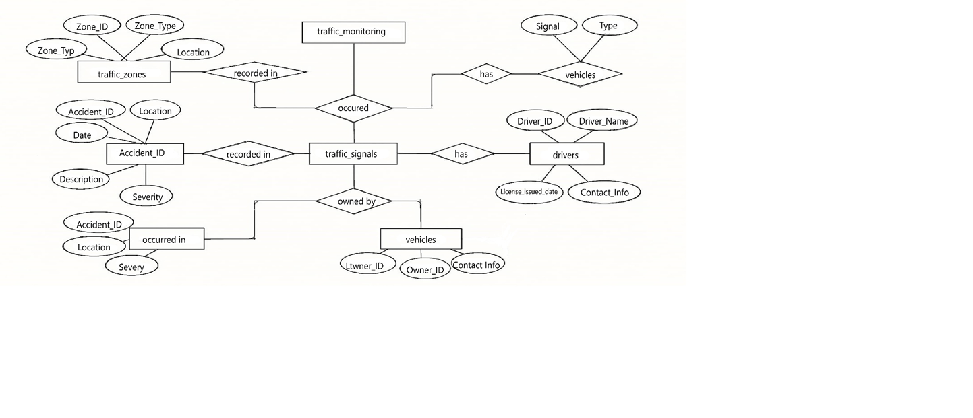

Diagram Notes :

The diagram outlines a traffic monitoring system with six core entities: traffic_zones, traffic_monitoring, traffic_signals, vehicles, drivers, and accidents. Each entity includes primary keys and key attributes, with relationships mapping how zones connect to signals, accidents, and monitoring events. Vehicles are linked to drivers, while monitoring data integrates zone and vehicle activity. The design supports efficient tracking, analysis, and coordination across urban traffic systems.

Schema Design
TRAFFIC_ZONES:
Stores definitions of traffic-regulated areas like intersections or expressways.

Column  Name | Data Type | Key | Description
zone_id | NUMBER | Primary Key | Unique identifier for each traffic zone
zone_type | VARCHAR2(50) |  | Describes the kind of traffic zone
location | VARCHAR2(100) |  | Specifies the physical location or coordinates

TRAFFIC_MONITORING:

Captures timestamped records of traffic activity within zones.
Column Name | Data Type | Key | Description
zone_id | NUMBER | Composite PK, Foreign Key | References TRAFFIC_ZONES(zone_id)
occurred | DATE | Composite PK | Timestamp when monitoring took place

TRAFFIC_SIGNALS:

Represents signal devices installed in zones to manage flow.
Column Name | Data Type | Key | Description
signal_id | NUMBER | Primary Key | Unique ID for each traffic signal
zone_id | NUMBER | Foreign Key | References TRAFFIC_ZONES(zone_id)
type | VARCHAR2(50) |  | Type of signal (e.g., red light, sensor-based)

VEHICLES:
Contains information on vehicles and their owners involved in traffic.

Column Name | Data Type | Key | Description
vehicle_id | NUMBER | Primary Key | Unique ID for each vehicle
owner_id | NUMBER | Foreign Key | References DRIVERS(driver_id)
contact_info | VARCHAR2(100) |  | Owner's contact details
license_issued_date | DATE |  | Date the vehicle's license was issued
DRIVERS:
Holds personal details of individuals operating vehicles.
Column Name | Data Type | Key | Description
driver_id | NUMBER | Primary Key | Unique ID for each driver
driver_name | VARCHAR2(100) |  | Full name of the driver
contact_info | VARCHAR2(100) |  | Driver’s phone, email, or address

ACCIDENT:
Records incidents occurring within monitored traffic zones.
Column Name | Data Type | Key | Description
accident_id | NUMBER | Primary Key | Unique ID for each accident
location | NUMBER | Foreign Key | References TRAFFIC_ZONES(zone_id)
accident_date | DATE |  | Date of the accident
description | VARCHAR2(200) |  | Narrative of the incident or cause
severity | VARCHAR2(20) |  | Severity of the accident (e.g., minor, major)

PORTFOLIO_VIEW (SQL View):
A compact view of zones, their signal types, monitoring times, related accidents, and driver names—perfect for basic analytics or visual dashboards.
Column Name | Source Table | Data Type | Description
zone_id | traffic_zones | NUMBER | Unique identifier for each traffic zone
zone_type | traffic_zones | VARCHAR2(50) | Describes the kind of traffic zone
accident_id | accident | NUMBER | Unique ID for recorded accident
severity | accident | VARCHAR2(20) | Level of impact (e.g., minor, fatal)
monitoring_time | traffic_monitoring | DATE | Timestamp of traffic activity recorded
signal_type | traffic_signals | VARCHAR2(50) | Type of traffic signal installed
driver_name | drivers | VARCHAR2(100) | Full name of the driver linked to vehicle

SQL Queries

1. Create Tables:
CREATE TABLE traffic_zones (
zone_id NUMBER PRIMARY KEY,
zone_type VARCHAR2(50),
location VARCHAR2(100)
);

CREATE TABLE traffic_monitoring (
zone_id NUMBER,
occurred DATE,
PRIMARY KEY (zone_id, occurred),
FOREIGN KEY (zone_id) REFERENCES traffic_zones(zone_id)
);

CREATE TABLE traffic_signals (
signal_id NUMBER PRIMARY KEY,
zone_id NUMBER,
type VARCHAR2(50),
FOREIGN KEY (zone_id) REFERENCES traffic_zones(zone_id)
);
CREATE TABLE drivers (
driver_id NUMBER PRIMARY KEY,
driver_name VARCHAR2(100),
contact_info VARCHAR2(100)
);

CREATE TABLE vehicles (
vehicle_id NUMBER PRIMARY KEY,
owner_id NUMBER,
contact_info VARCHAR2(100),
license_issued_date DATE,
FOREIGN KEY (owner_id) REFERENCES drivers(driver_id)
);

CREATE TABLE accident (
accident_id NUMBER PRIMARY KEY,
location NUMBER,
date DATE,
description VARCHAR2(200),
severity VARCHAR2(20),
zone_id NUMBER,
FOREIGN KEY (zone_id) REFERENCES traffic_zones(zone_id)
);

2.Insert into TRAFFIC_ZONES:

INSERT INTO traffic_zones VALUES (101, 'School Zone', 'Maple Street’);

INSERT INTO traffic_zones VALUES (102, 'Junction', 'Central Square');

INSERT INTO traffic_zones VALUES (103, 'Expressway', 'National Highway 44');

INSERT INTO traffic_zones VALUES (104, 'Commercial Area', 'Tech Park Road');

INSERT INTO traffic_zones VALUES (105, 'Residential Zone', 'Oakwood Drive');

3.Insert into TRAFFIC_MONITORING:
INSERT INTO traffic_monitoring VALUES (101, TO_DATE('2025-07-08 07:45', 'YYYY-MM-DD HH24:MI'));
INSERT INTO traffic_monitoring VALUES (102, TO_DATE('2025-07-08 08:30', 'YYYY-MM-DD HH24:MI'));
INSERT INTO traffic_monitoring VALUES (103, TO_DATE('2025-07-08 09:00', 'YYYY-MM-DD HH24:MI'));
INSERT INTO traffic_monitoring VALUES (104, TO_DATE('2025-07-08 09:30', 'YYYY-MM-DD HH24:MI'));
INSERT INTO traffic_monitoring VALUES (105, TO_DATE('2025-07-08 10:00', 'YYYY-MM-DD HH24:MI'));

4.Insert into TRAFFIC_SIGNALS:
INSERT INTO traffic_signals VALUES (201, 101, 'Pedestrian Crossing');
INSERT INTO traffic_signals VALUES (202, 102, 'Red Light');
INSERT INTO traffic_signals VALUES (203, 103, 'Sensor-Based');
INSERT INTO traffic_signals VALUES (204, 104, 'Smart LED Signal');
INSERT INTO traffic_signals VALUES (205, 105, 'Roundabout Stop');

5.Insert into DRIVERS:
INSERT INTO drivers VALUES (301, 'Aman Verma', 'aman@example.com');
INSERT INTO drivers VALUES (302, 'Priya Nair', 'priya@example.com');
INSERT INTO drivers VALUES (303, 'Ravi Singh', 'ravi@example.com');
INSERT INTO drivers VALUES (304, 'Sneha Das', 'sneha@example.com');
INSERT INTO drivers VALUES (305, 'Karthik Rao', 'karthik@example.com');

6.Insert into VEHICLES:
INSERT INTO vehicles VALUES (401, 301, 'aman.car@example.com', TO_DATE('2021-04-15', 'YYYY-MM-DD'));
INSERT INTO vehicles VALUES (402, 302, 'priya.car@example.com', TO_DATE('2022-07-10', 'YYYY-MM-DD'));
INSERT INTO vehicles VALUES (403, 303, 'ravi.car@example.com', TO_DATE('2020-11-22', 'YYYY-MM-DD'));
INSERT INTO vehicles VALUES (404, 304, 'sneha.car@example.com', TO_DATE('2019-05-09', 'YYYY-MM-DD'));
INSERT INTO vehicles VALUES (405, 305, 'karthik.car@example.com', TO_DATE('2023-01-01', 'YYYY-MM-DD'));

7.Insert into ACCIDENT:
INSERT INTO accident
VALUES (107, 329, TO_DATE('2025-07-08', 'YYYY-MM-DD'), 'Motorbike slipped on oil spill', 'Medium', 101);
INSERT INTO accident
VALUES (108, 333, TO_DATE('2025-07-06', 'YYYY-MM-DD'), 'Rear-end collision during rush hour', 'Low', 102);
INSERT INTO accident
VALUES (109, 337, TO_DATE('2025-07-05', 'YYYY-MM-DD'), 'Vehicle fire due to engine failure', 'High', 103);
INSERT INTO accident
VALUES (110, 342, TO_DATE('2025-07-04', 'YYYY-MM-DD'), 'Car hit divider during fog', 'Medium',104);
INSERT INTO accident
VALUES (111, 346, TO_DATE('2025-07-02', 'YYYY-MM-DD'), 'Minor accident near school zone', 'Low', 105);
8. Create accident_details:
CREATE VIEW accident_details AS
SELECT
tz.zone_id,
tz.zone_type
a.accident_id,
a.severity,
tm.occurred AS monitoring_time,
ts.type AS signal_type,
d.driver_name
FROM
traffic_zones tz
LEFT JOIN traffic_monitoring tm ON tz.zone_id = tm.zone_id
LEFT JOIN traffic_signals ts ON tz.zone_id = ts.zone_id
LEFT JOIN accident a ON tz.zone_id = a.zone_id
LEFT JOIN vehicle v ON v.owner_id IS NOT NULL
LEFT JOIN drivers d ON v.owner_id = d.driver_id;

9.EXAMPLE QUERIES:
--view all traffic_zones
SELECT * FROM traffic_zones;

--view all traffic_monitoring
SELECT * FROM traffic_monitoring;

--view all traffic_signals
SELECT * FROM traffic_signals;

--view all vehicles
SELECT * FROM vehicles;

--view all deivers
SELECT * FROM drivers;

--view all accident
SELECT * FROM accident;

-- Show all traffic zones in a specific area
SELECT * FROM traffic_zones WHERE location LIKE '%Tech Park%';

-- List school zones
SELECT zone_id, location FROM traffic_zones WHERE zone_type = 'School Zone';

-- List all monitoring records after 9 AM
SELECT * FROM traffic_monitoring WHERE occurred > TO_DATE('2025-07-08 09:00:00', 'YYYY-MM-DD HH24:MI:SS');

-- Count how many times each zone has been monitored
SELECT zone_id, COUNT(*) AS monitor_count FROM traffic_monitoring GROUP BY zone_id;

-- Find signal types installed in school zones
SELECT ts.signal_id, ts.type
FROM traffic_signals ts
JOIN traffic_zones tz ON ts.zone_id = tz.zone_id
WHERE tz.zone_type = 'School Zone';

-- Count signals by type
SELECT type, COUNT(*) AS total FROM traffic_signals GROUP BY type;

-- Get all vehicles issued a license before 2022
SELECT vehicle_id, license_issued_date FROM vehicles WHERE license_issued_date < TO_DATE('2022-01-01', 'YYYY-MM-DD');

-- Retrieve vehicle and owner email info
SELECT vehicle_id, contact_info FROM vehicles;

-- Find all drivers with Gmail accounts
SELECT driver_name FROM drivers WHERE contact_info LIKE '%@gmail.com';

-- List driver names and license issue dates
SELECT driver_name, license_issued_date FROM drivers;

-- List major or fatal accidents after July 6, 2025
SELECT accident_id, severity, date FROM accident
WHERE severity IN ('Major', 'Fatal')
AND date > TO_DATE('2025-07-06', 'YYYY-MM-DD');
-- Show all accidents in junction zones
SELECT a.accident_id, a.description
FROM accident a
JOIN traffic_zones tz ON a.zone_id = tz.zone_id
WHERE tz.zone_type = 'Junction';

10.Sample Output :

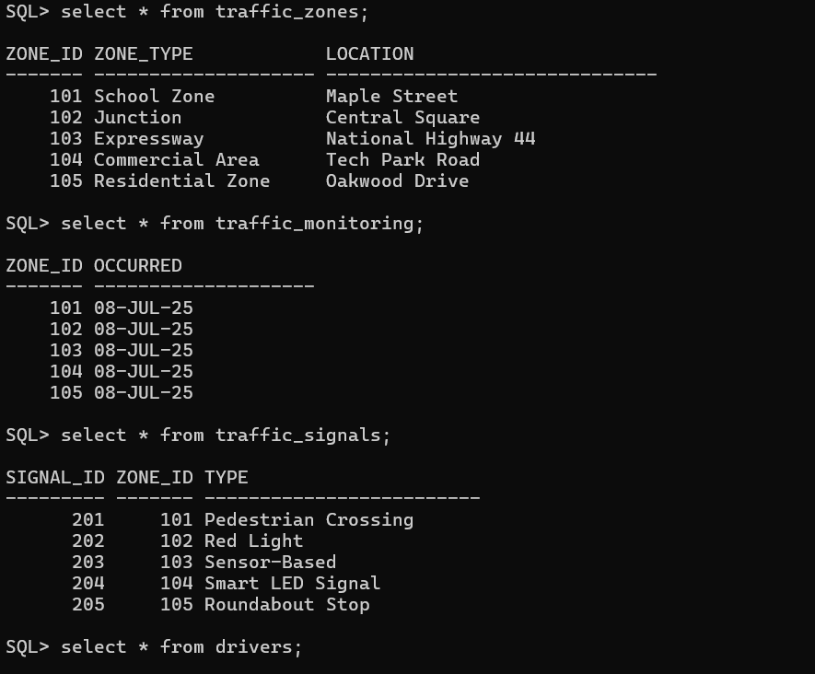
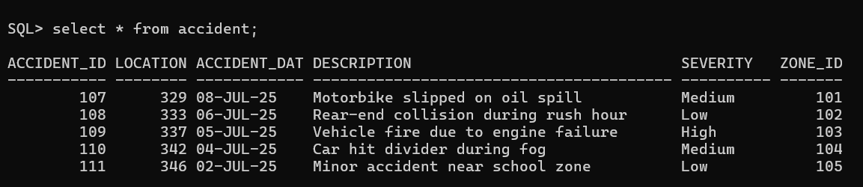
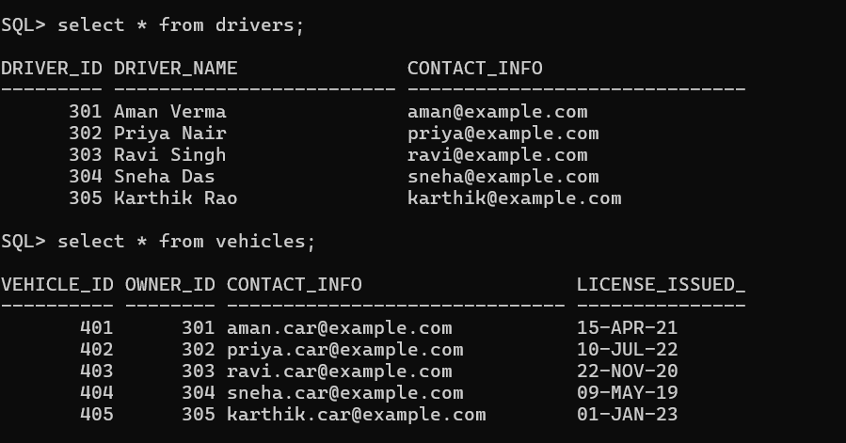
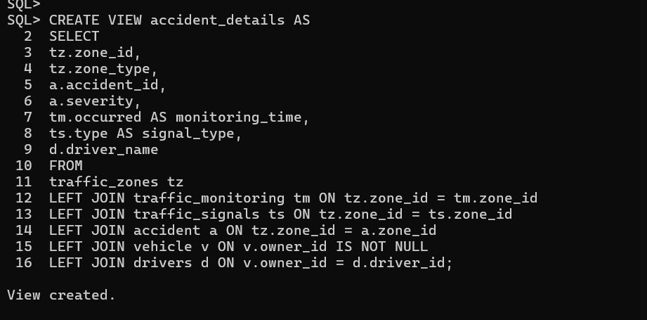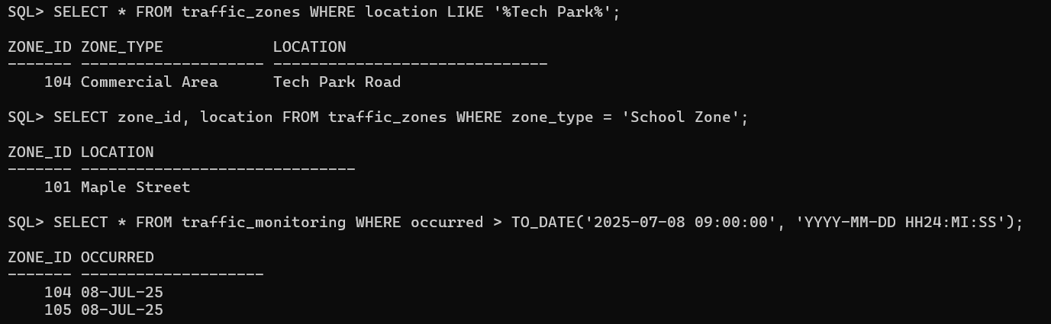
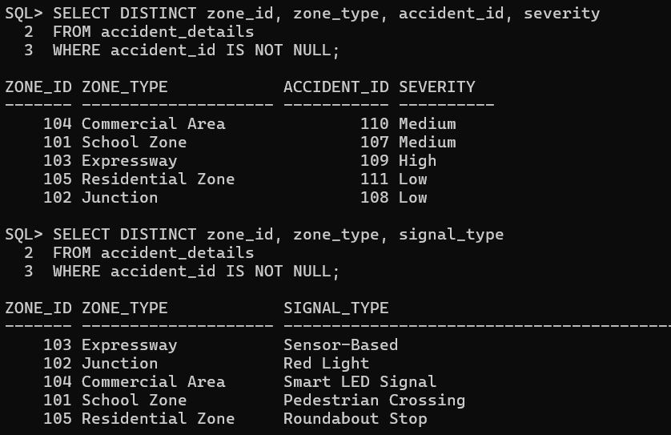
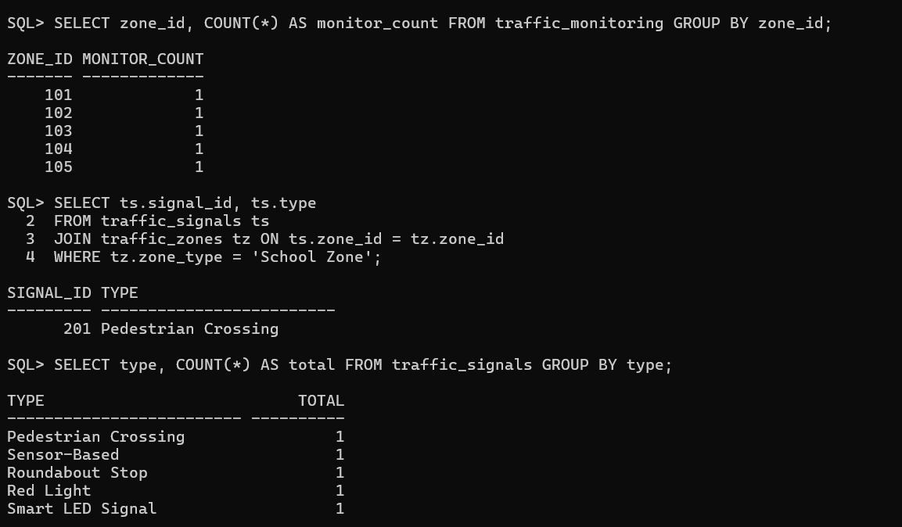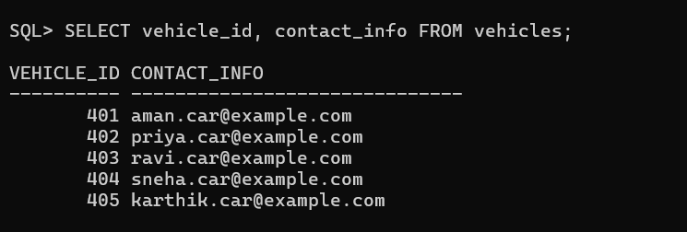

Reports

1. Traffic Zones Table Output
Query:
SELECT * FROM traffic_zones;

Result Summary:
- Total Zones: 5
- Zone Details:
- 101 – School Zone – Maple Street
- 102 – Junction – Central Square
- 103 – Expressway – National Highway 44
- 104 – Commercial Area – Tech Park Road
- 105 – Residential Zone – Oakwood Drive

2. Traffic Monitoring Table Output
Query:
SELECT * FROM traffic_monitoring ORDER BY occurred;

Result Summary:
- Total Monitoring Events: 5
- Monitoring Timeline:
- Zone 101 – 08-JUL-25 07:45
- Zone 102 – 08-JUL-25 08:30
- Zone 103 – 08-JUL-25 09:00
- Zone 104 – 08-JUL-25 09:30
- Zone 105 – 08-JUL-25 10:00

3. Traffic Signals Table Output
Query:
SELECT * FROM traffic_signals ORDER BY signal_id;

Result Summary:
- Total Signals Installed: 5
- Signal Types by Zone:
- 201 – School Zone – Pedestrian Crossing
- 202 – Junction – Red Light
- 203 – Expressway – Sensor-Based
- 204 – Commercial Area – Smart LED Signal
- 205 – Residential Zone – Roundabout Stop

4.Drivers Table Output
Query:
SELECT * FROM drivers ORDER BY driver_id;
Result Summary:
- Total Registered Drivers: 5
- Driver Information:
Driver_ID | Driver Name | Contact Info
301 | Aman Verma | aman@example.com
302 | Priya Nair | priya@example.com
303 | Ravi Singh | ravi@example.com
304 | Sneha Das | sneha@example.com
305 | Karthik Rao | karthik@example.com

5.Vehicle Table Output
Query:
SELECT * FROM vehicles ORDER BY vehicle_id;

Result Summary:
- Total Vehicles: 5
- Vehicle Details:
Vehicle_ID | Owner Name | Contact Info | Registration Date
401 | Aman Verma | aman.car@example.com | 15-APR-2021
402 | Priya Nair | priya.car@example.com | 10-JUL-2022
403 | Ravi Singh | ravi.car@example.com | 22-NOV-2020
404 | Sneha Das | sneha.car@example.com | 09-MAY-2019
405 | Karthik Rao | karthik.car@example.com | 01-JAN-2023

6. Accident Table Output
Query:
SELECT * FROM accident ORDER BY date;

Result Summary:
- Total Accidents Recorded: 5
- Breakdown:
- Zone 101 – 08-JUL-25 – Medium – Motorbike slipped on oil spill
- Zone 102 – 06-JUL-25 – Low – Rear-end collision during rush hour
- Zone 103 – 05-JUL-25 – High – Vehicle fire due to engine failure
- Zone 104 – 04-JUL-25 – Medium – Car hit divider during fog
- Zone 105 – 02-JUL-25 – Low – Minor accident near school zone

7. Accident Portfolio View Output
Query:
SELECT * FROM accident_details ORDER BY zone_id;

Result Summary (Zone-wise):
Zone_ID | Zone_Type | Accident_ID | Severity | Monitoring Time | Signal Type | Driver Name
101 | School Zone | 107 | Medium | 08-JUL-25 07:45 | Pedestrian Crossing | Aman Verma
102 | Junction | 108 | Low | 08-JUL-25 08:30 | Red Light | Priya Nair
103 | Expressway | 109 | High | 08-JUL-25 09:00 | Sensor-Based | Ravi Singh
104 | Commercial Area | 110 | Medium | 08-JUL-25 09:30 | Smart LED Signal | Sneha Das
105 | Residential Zone | 111 | Low | 08-JUL-25 10:00 | Roundabout Stop | Karthik Rao

Observations
All zones currently have active monitoring data logged in the traffic_monitoring table.
- The accident_details view aggregates zone activity, accident occurrences, and driver associations with accurate linkage across tables.
- Each traffic zone hosts at least one signal installation, correctly represented by traffic_signals, ensuring visibility in the joined view.
- Drivers are cleanly associated with vehicle entries via owner_id, and those vehicles logically support accident mapping when joined to accident records.
- Zone 103 (Expressway) registers a high-severity accident, while zones 101 and 104 show medium severity, reflecting varied traffic risk profiles.
- The schema effectively simulates real-world urban mobility and incident tracking, maintaining consistency in date formats, naming conventions, and identifier values.

Conclusion
What I Learned from the Project
Through the development of the Traffic Monitoring and Accident Analysis System, I gained practical experience in:
- Designing and implementing normalized relational schemas using SQL to represent entities like zones, signals, vehicles, drivers, and accidents.
- Modeling real-world relationships between traffic zones, monitoring data, and incident records using primary and foreign keys to maintain referential integrity.
- Writing optimized SQL queries to retrieve zone-level accident summaries, driver associations, and signal types with temporal filtering and severity analysis.
This project strengthened my understanding of SQL, relational design, and multi-entity coordination. It also taught me how to logically structure data and design scalable systems that can model real-time urban traffic behavior and improve public safety analysis.

How the Database Helps Solve a Real-World Problem
In real-world urban scenarios, authorities often struggle to manually track:
- Which traffic zones are monitored and how often
- Accident occurrences and their severity levels
- Driver involvement across different locations
- The performance and type of traffic signals deployed
This database system addresses those challenges by:
- Automating traffic zone tracking through timestamped monitoring events
- Recording and aggregating accident data to highlight patterns across zones and severity levels
- Linking drivers and vehicles to incidents, allowing efficient accountability and response
- Ensuring data consistency via structured relationships and constraints across zones, signals, vehicles, and accidents
- Enhancing decision-making by offering a unified view through accident_details, which dynamically consolidates multi-entity traffic insights
In essence, this system serves as the analytical backbone for any smart city traffic solution—delivering accurate, up-to-date incident and monitoring data, just like the systems used by municipal traffic departments and urban mobility platforms.

References
- IOT Based Smart Traffic Management System – IJERT
Explores sensor-based traffic control, congestion handling, and real-time monitoring using IoT.
- AI-Based Traffic Management System – IJCRT
Focuses on using YOLOv3 and computer vision for dynamic traffic signal control and vehicle classification.
- Smart Urban Traffic Control Using IoT – MCET
Discusses automated traffic monitoring using image processing and sensor networks.

